Question 3 — Self-Healing Deployment: Probes, Resources, Quota, Rolling Update, Rollback

Part A: Namespace Governance
- Show with kubectl describe
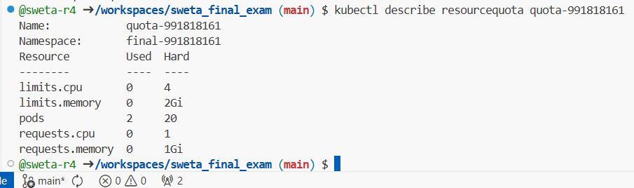

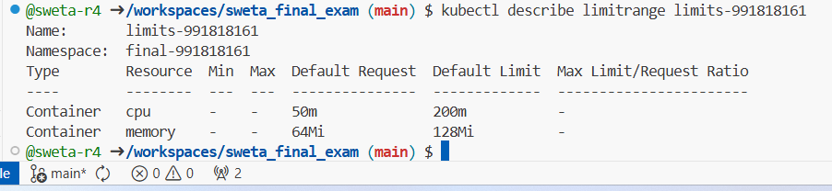

Part B – Deployment with three probes and Service

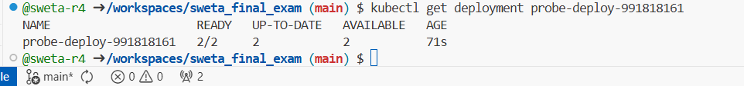

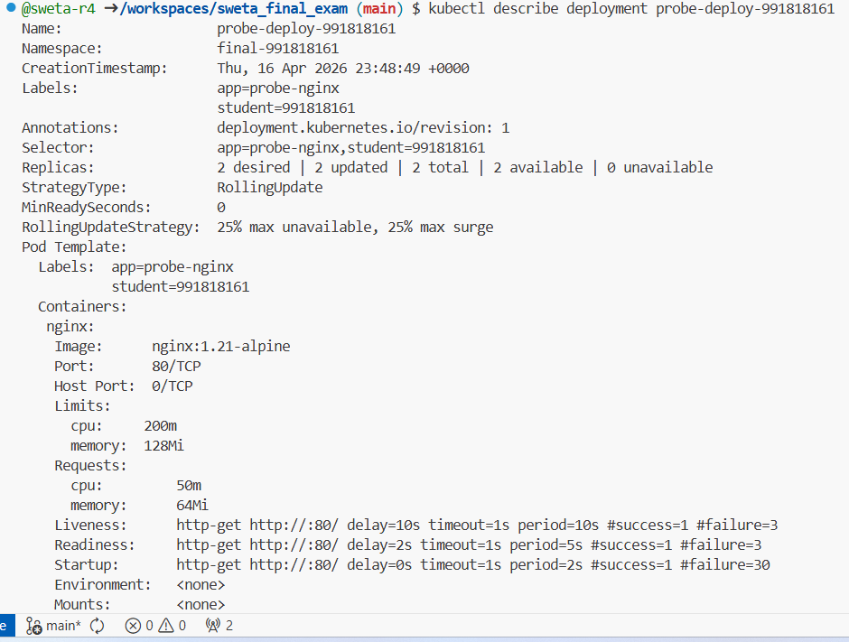
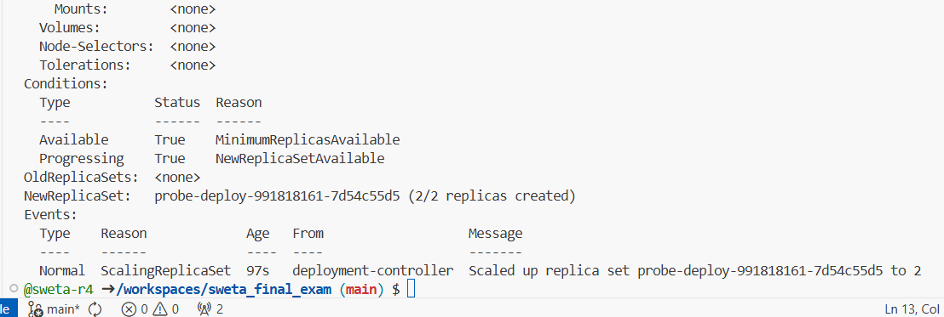

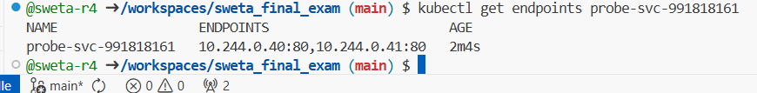

Part C – Rolling update and rollback
- Set rolling update strategy (edit the existing deployment):

- First rolling update (good image):
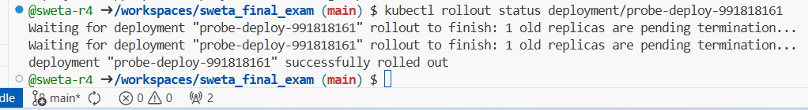

- Second rolling update (bad image):

- New Pods created ImagePullBackOff
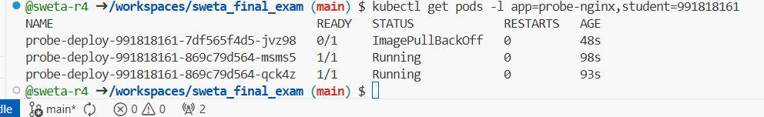

- Confirming stall

- Roll back:
- After the good update

- After bad image (show ImagePullBackOff)
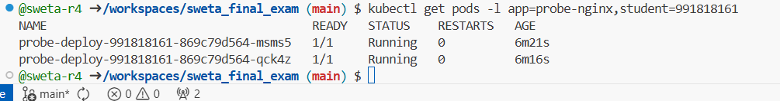

- After rollback
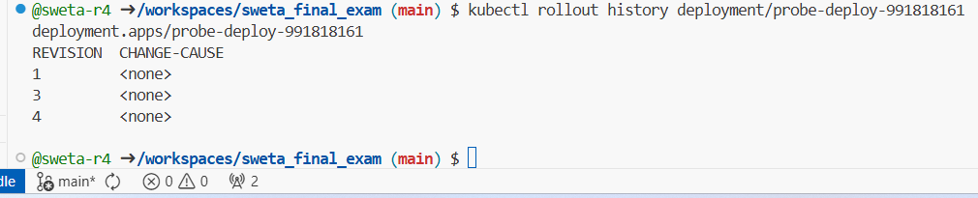

I configured a LimitRange and ResourceQuota to govern namespace resources, then created a Deployment with startup, readiness, and liveness probes plus explicit CPU/memory limits. After setting rolling update strategy (maxSurge:1, maxUnavailable:0), I performed a successful update to nginx:1.22-alpine, then a failed update to a bad image causing ImagePullBackOff while old Pods kept serving traffic. Finally, I rolled back successfully and showed rollout history with multiple revisions, proving production-grade deployment management.

YAML Manifests Used

